Association of pre- and post- dialysis uric acid difference to left ventricular structural and functional disorders in maintenance hemodialysis patients
Authors: Samar Ahmed Sayed Ahmed Omran, Prof. Dr. El-Metwally Lotfy El-shehawy, Assist. Prof. Mohamed El-Tantawy Ibrahim, Dr. Saddam Hassan Abdelaziz, Dr. Sherin Mostafa Ahmed
Abstract
Background: The hallmark of gout is hyperuricemia. This substance is linked to the pathophysiology of cardiovascular disease, the primary cause of death among dialysis patients. Hyperuricemia is associated with cardiovascular conditions including hypertension, diabetes, and insulin resistance. High SUA levels prevent mortality from all causes. Relationships between SUA and all-cause mortality were J-shaped, according to smaller studies. In keeping with SUA's role in protein metabolism, new study indicates that it may be employed as a nutritional status indicator in hemodialysis patients. Rather than a high SUA, a superior nutritional state may explain survival connections. In HD patients, LVH with diverse etiologies is predictive of CV mortality and morbidity.
Aim: to study the association of pre and post – dialysis uric acid difference to left ventricular structural and functional disorders in maintenance hemodialysis patients.
Subject and Methods: This study was carried out on ESRD Patients in internal medicine department of Benha University in the hemodialysis unit, where 100 patients were selected. Results: There were high statistically significant differences between the studied patients systolic and diastolic blood pressure before and after hemodialysis. There were high statistically significant differences between the studied patient’s serum level of uric acid, creatinine and urea before and after hemodialysis.
Conclusion: This study showed that there was significant correlation between uric acid and LV ejection fraction as well as LV parameters. In regression analysis we found that serum uric acid was a significant predictor of LV ejection fraction.
Key words: pre- and post- dialysis uric acid, Left ventricular, Hemodialysis.

Introduction
Uric acid is the end product of purine metabolism and is eliminated by renal (60% - 70%) and intestinal (30% - 40%) excretion (Ahmad et al.,2019_Bae et al.,2016) Consequently, declining renal function is associated with elevations in serum uric acid(SUA), and 40% to 80% of patients with end-stage renal disease (ESRD) have hyperuricemia, typically deﬁned as SUA levels <7 mg/dl (416 mmol/l) (bae et al.,2016) In patients treated with hemodialysis, SUA is efﬁciently removed from blood, given its clearance pattern and sieving coefﬁcient (1.01) similar to that of urea; thus, during one hemodialysis session on average 1 g uric acid is eliminated (bae etal.,2016)
Typically, hyperuricemia is the hallmark of gout. Moreover, detrimental pathophysiological effects have been attributed to this compound and linked to the pathogenesis of cardiovascular disease, the main cause of mortality in dialysis patients (Beberashvili etal.,2016) Despite its antioxidant properties, uric acid was found to activate inﬂammatory pathways in the body such as the NACHT, LRR and PYD domains (NALP3) inﬂammasome, leading to secretion of interleukin-1b and reactive oxygen species. In addition, uric acid triggers endothelial dysfunction and stimulates the renin angiotensin aldosterone system, thus contributing to vascular smooth muscle cell growth and arterial function impairment (Beberashvili et al.,2015_ Bengtsson et al.,1988)
In line with this, hyperuricemia has been associated with conditions associated with cardiovascular disease, such as hypertension, diabetes mellitus, and insulin resistance (Bae etal.,2016_ Bobulescu IA, Moe OW.,2012) Although there is agreement on the association between high SUA levels and the risk of all cause as well as cardiovascular related mortality in the general population(Go etal.,2004_ Hsu etal.,2004), studies exploring the role of SUA in the context of high risk of mortality and cardiovascular disease of ESRD patients are inconclusive, reporting direct, inverse, or different forms of associations (Hsu WL etal.,2017_ Park etal.,2017) The 4 largest cohort studies, including data from the Dialysis Outcomes and Practice Patterns Study (DOPPS; n5827) (Murea M, Tucker BM.,2019), DaVita Inc (n4298) ( Park etal.,2017),Korean Society of Nephrology registry (n7333) (Muiesan etal.,2016) and Taiwan Society of Nephrology dialysis registry.(n27,229)( Masuo etal.,2003) found high SUA levels to be associated with lower risk for all-cause mortality. In another large cohort study from Asia with 1738 patients (Hsu WL etal.,2017), a U-shaped association between SUA and all-cause mortality was found, whereas further smaller studies found J-shaped associations (Latif etal.,2011_Silbernagel etal.,2013), Discrepancies in study results may be explained by differences in cohort characteristics, low power, as well as the possibility of residual confounding. Regarding the latter, and in line with SUA’s role in protein metabolism, recent studies pinpointed that SUA may be considered as a marker of the nutritional status among patients undergoing hemodialysis (Kim etal.,2017_Park etal.,2017) and suggested that a better nutritional status and not a high SUA is likely to explain survival associations.
A better understanding of the reasons behind these paradoxical ﬁndings is fundamental to determine target SUA levels for hemodialysis patients.
Left ventricular hypertrophy (LVH) with multifactorial etiology is an important predictor of CV mortality and morbidity in HD patients. In the last decade, numerous cross sectional clinical studies have investigated the association between UA and LVH in the general population, hypertensive cohorts and patients with diabetes and renal failure (Suliman etal.,2006 _zeng etal.,2017)). The Pressioni Arteriose Monitorate E Loro Associazioni 10-year follow-up study (Cuspidi etal.,2017) is the first study that showed UA is a predictor of long-term echocardiographic changes from normal left ventricular mass index (LVMI) to LVH in a community sample. However, to our knowledge, there is no information in the literature on the clinical effect of longitudinal changes in serum UA levels on LVH in HD patients, and hence this is the first clinical study to assess the relationship between serum UA level and LVH in HD patients.
Patients and Methods
Patients:
This study was carried out on ESRD Patients in internal medicine department of benha university in the hemodialysis unit, where 100 patients was selected from the beginning of dialysis and follow up according to their serum uric acid difference pre- and post-dialysis and left ventricular parameters.
Methods:
This prospective study was carried on ESRD patient who began dialysis in our hemodialysis unit, and follow up every six months for about one year according to serum uric acid difference pre and post dialysis sessions with left ventricular structural and functional parameter by monitoring next laboratory and radiological investigations.
Regression analysis was conducted to study the correlation between FA- SUA (Follow up- Averaged Serum Uric Acid) and LV parameters and MACEs (Major Adverse Cardiovascular Events including ACS, CVS and Cardiovascular mortality).
• Inclusion criteria:
Patients with ESRD started dialysis and became on regular hemodialysis.
• Exclusion criteria:
Age less than 18-year-old, patients with tumor lysis syndrome or on chemotherapy, pregnancy and patients with thyroid diseases.
All of them was subjected to the following procedures after taking their written consents.
- History taking included:
- Age (years)
- Gender
- Duration of hemodialysis (months)
- Clinical examination:
- Blood pressure: systolic and diastolic blood pressure pre- and post-dialysis (mmHg).
- Body mass index (BMI).
- The blood tests considered in our plan:
- Serum Uric acid (mg/dL) pre- and post-dialysis
- Pre- and post- dialysis uric acid difference= pre-dialysis serum uric acid level minus post-dialysis serum uric acid level
- Hemoglobin (g/dl)
- Serum albumin (g/dl)
- Serum Creatinine (mg/dL)
- Serum urea (mg/dL)
- Serum sodium (mEq/L)
- Serum potassium (mEq/L)
- Serum calcium(mg/dL)
- Serum phosphorus(mg/dL)
- Parathyroid hormone(ng/dL)
- Lipid profile
- C-Reactive protein (CRP)

- Imaging:
- Electrocardiography: Twelve lead surface ECG will be done for each patient.
- Echocardiography:
A) Conventional transthoracic echocardiography (TTE);
Two-dimensional echocardiography and Doppler examination were performed with a commercially available ultrasound system (Philips, Epic 7c, equipped with a 5.5 X transducer). LA and left ventricular (LV) measurements was taken using the two-dimensionally guided M-mode, (2D), conventional Doppler on mitral inflow.
A two-dimensional echocardiographic study was used to assess:
• LV ejection fraction by modified Simpson biplane method, fractional shortening (FS) and LV diameters (both end-systolic and end-diastolic diameters).
• Left ventricular mass and left ventricular mass indexed to body surface area estimated by LV cavity dimension and wall thickness at end diastole (19).
LV Mass (g) =0.8{1.04(((LVEDD + IVSd +PWd)3 - LVEDD3))} + 0.6
Pulsed Doppler transmitral flow:
Mitral inflow patterns by pulsed wave Doppler examination demonstrate passive ventricular filling in early diastole (E wave) and late 7 active filling phase during atrial contraction (A wave). The sample volume is placed at the tips of the mitral leaflets in the apical four-chamber view.
B) Tissue Doppler Imaging:
For analysis of the TDI derived strain of LA chamber, apical four chambers and two-chamber view images will be obtained using conventional two-dimensional echocardiography, during breath hold, with a stable ECG recording.
The pulsed wave TDI sample volume will be placed on the mitral annulus in the apical four- and two-chamber views.
Pulsed wave tissue Doppler imaging (TDI) was performed in the apical views to acquire mitral annular velocities. Measurements included the systolic (S) and early diastolic (E′) .

Six months and one year follow up:
A. Major adverse cardiovascular events:
- coronary artery disease.
- Heart failure.
- Stroke
- Arrhythmia
- DM and metabolic syndrome.
- Hypertension.
- Other cause mortality
B. Electrocardiography.
C. Echocardiography:
The previous echocardiographic parameters were reassessed again.
Data management and statistical analysis: -
The collected data was recorded then presented, and statistically analyzed by computer using Statistical Package for the Social Sciences (SPSS) 22.0 for windows (SPSS Inc., Chicago, IL, USA) as follow:
- Editing and coding.
- Data entry in computer.
- Data were summarized and presented in tables and graph.
- The normality of distribution for the
- analyzed variables were tested using Kolmogorov-Smirnov test. The collected data were summarized in terms of mean ± Standard Deviation (SD) for parametric data, median and Inter Quartile Range (IQR) for nonparametric data as appropriate and as number and percentage for qualitative data. Comparisons between the different study patients were carried out using paired t-test & repeated measures ANOVA test to compare parametric quantitative data (mean and SD) and Wilcoxon test & Friedman ANOVA test to compare non parametric quantitative data (median &IQR) and post HOC test was done to detect differences between patients. Spearman correlation between non parametric quantitative data was done.
- Linear regression for predictors of quantitative data was done.
- All tests were two sided. The accepted level of significance in this work was (p <0.05), p ≤ 0.001 was considered highly statistically Significant (HS), and p > 0.05 was considered Non statistically Significant (NS).

Results
Table 1: Demographic characteristics of the studied patients:

All patients (n= 100) |  |  | Median |  | IQR | Mean ±SD
Age (years) |  | 39.00 |  | 27 - 51.75 |  | 39.6±13.4
BMI (kg/m²) |  | 28.34 |  | 22.8 - 31.6 |  | 27.6±5.3
Gender | Male | 54 |  | 54.0%
 | Female | 46 |  | 46.0%

Table (1) shows that the 54 % of the studied patients were males, the median age of the studied patients was 39 years old, mean +_ SD of the age of studied patients was (39.6+-13.4) years old and the median BMI was (28.34 kg/m2), the mean +_SD of BMI were (27.6+-5.3) kg/m2.

Table (2) Laboratory investigations of the studied patients:
All patients (n= 100) | Mean ± SD
Hemoglobin (g/dl) | 8.63 ± 1.244
Serum albumin (g/dl) | 3.56 ± 0.624
Serum sodium (mEq/L) | 143.03 ± 5.943
Serum potassium (mEq/L) | 5.37 ± 0.459
Serum calcium(mg/dL) | 8.71 ± 0.717
Serum phosphorus(mg/dL) | 4.70 ± 1.386
PTH (ng/dl) | 270.95 ± 68.082
CRP (mg/L) | 4.53 ± .827

Table (2) shows that median serum sodium, potassium, calcium and phosphorus level of the studied patients were 142.5 mEq/L, 5.4 mEq/L, 8.5 mg/dL and 4.7 mg/dL respectively and mean +_SD of serum sodium, potassium, calcium and phosphorus were (143+_5.94 MEq/L, 5.37 +_0.46MEq/L, 8.7+_0.72 mg/dL and 4.7+_ 1.39 mg/dl) respectively.
The median CRP level of the studied patients was (4.6 mg/L) and mean +_SD were (4.5 +_0.83 mg/L).

.
Table (3)Systolic blood pressure (SBP) and diastolic blood pressure (DBP) of the studied patients before and after hemodialysis:
All patients (n= 100) |  | Mean ± SD | Paired t test | P value
SBP  (mmHg) | Pre-dialysis | 153.2±22.8 | 16.289 | ˂ 0.001  (HS)
 | Post-dialysis | 133.6±14.3
DBP  (mmHg) | Pre-dialysis | 97.3±8.02 | 17.060 | ˂ 0.001  (HS)
 | Post-dialysis | 84.4±5.13

Table (3) shows that there were high statistically significant differences between the studied patients systolic and diastolic blood pressure before and after hemodialysis (p ˂ 0.001). the mean +_SD of SBP was (133.6 +_14.3 mmHg) and diastolic blood pressure mean +_SD of DBP was (84.4 +_ 5.13 mmHg) of the studied patients had significantly decreased after hemodialysis.
Table (4) Serum uric acid, creatinine, and urea levels before and after hemodialysis among studied patients:

All patients (n= 100) |  | Mean ± SD | Paired t test | P value
Serum Uric acid (mg/dL) | Pre-dialysis | 8.1±2.8 | 6.567 | ˂ 0.001  (HS)
 | Post- dialysis | 7.7±2.6
Serum Creatinine (mg/dL) | Pre-dialysis | 11.7±1.5 | 40.565 | 0.000  (HS)
 | Post- dialysis | 5.04±0.87
Serum urea (mg/dL) | Pre-dialysis | 281.6±53.2 | 33.629 | 0.000  (HS)
 | Post- dialysis | 92.4±15.1

Table (4) shows that there were high statistically significant differences between the studied patients serum level of uric acid, creatinine and urea before and after hemodialysis (p ˂ 0.001). the mean +_SD of uric acid, creatinine and urea level had significantly decreased after hemodialysis (7.7 +_2.6mg/dl) , (5.04 +_0.87mg/dl) and (92.4 +_ 15.1 mg/dl) respectively.
Table (5) LV ejection fraction pre-and post-dialysis among studied patients:
LV ejection fraction (%) | Mean ±SD | Repeated measure  ANOVA  Test | P-value
Pre-dialysis (%) | 44.2±5.5 | 7.291 | ˂ 0.001  (HS)
6 months post dialysis (%) | 44.6±5.5
12 months post dialysis (%) | 45.2±5.4

Table (5) shows that there were high statistically significant differences between the studied patients LV ejection fraction before and after 6 and 12 months of hemodialysis (p ˂ 0.001). LV ejection fraction has significantly increased on 6 and 12 months follow up after hemodialysis. the mean +_SD of LV ejection fraction before and after 6 and 12 months of hemodialysis were (44.2 +_ 5.5) %, (44.6 +_ 5.5) %, (45.2 +_ 5.4) % respectively.

Table (6) left ventricular mass pre- and post- dialysis among studied patients:
Left ventricular mass  (gram) | Mean ± SD | Repeated measure  ANOVA | P-value
Pre-dialysis (g) | 42.5±6.9 | 31.107 | .000  (HS)
6 months post dialysis  (g) | 40.9±7.2
12 months post dialysis  (g) | 40.2±6.6

Table (6) shows that there were high statistically significant differences between the studied patients left ventricular mass before and after 6 and 12 months of hemodialysis (p ˂ 0.001). Left ventricular mass has significantly decreased on 6 and 12 months follow up after hemodialysis. the mean +_ SD of LV mass before and after 6 and 12 month was (42.5 +_ 6.9) gram, (40.9 +_ 7.2) gram, (40.2 +_ 6.6) gram respectively.

Table (7) left ventricular mass index pre -and post-dialysis among studied patients:
Left ventricular mass index  (g/m2) | Mean ± SD | Repeated measure  ANOVA | P-value
Pre-dialysis (g/m2) | 26.9±6.88 | 28.276 | .000  (HS)
6 months post dialysis  (g/m2) | 24.8±5.3
12 months post dialysis  (g/m2) | 24.3±5.1

Table (7) shows that there were high statistically significant differences between the studied patients left ventricular mass index before and after 6 and 12 months of hemodialysis (p ˂ 0.001). Left ventricular mass index has significantly decreased on 6 and 12 months follow up after hemodialysis. the mean +- SD of LV mass index before and after hemodialysis were (26.9 +- 6.88 g/m2) ,(24.8 +- 5.3 g/m2) and (24.3 +- 5.1 g/m2) respectively.

Table (8) Tissue doppler echocardiography E′ wave pre and post dialysis among studied patients:
E′ wave (cm/sec) | Mean ± SD | Repeated measure  ANOVA  Test | P value
Pre-dialysis (cm/sec) | 3.92±0.89 | 33.084 | ˂ 0.001  (HS)
6 months post dialysis  (cm/sec) | 4.42±0.55
12 months post dialysis  (cm/sec) | 4.54±0.61

Table (8) shows that there were high statistically significant differences between the studied patients E′ wave before and after 6 and 12 months of hemodialysis (p ˂ 0.001). E′ wave significantly increased after 6 and 12 months of hemodialysis. E` wave (represents the left ventricular diastolic function). The mean +_SD of E` wave were (3.9 +_0.89 cm/sec), (4.42 +_0.55 cm/sec), (4.54 +_0.61 cm/sec) respectively.

Table (9) Tissue doppler echocardiography S wave pre and post dialysis among studied patients:
S wave (cm/sec) | Mean ± SD | Repeated measure  ANOVA  Test | P value
Pre-dialysis(cm/sec) | 3.89 ± 0.63 | 23.9 | ˂ 0.001  (HS)
6 months post dialysis  (cm/sec) | 3.79 ± 0.60
12 months post dialysis  (cm/sec) | 3.58 ± 0.55
Table (9) shows that there was high statistically significant decrease of patients S wave after 6 and 12 months of hemodialysis (p ˂ 0.001). S wave (represents systolic annular velocity of left ventricle), The mean ± SD of S wave level before hemodialysis and after 6 and 12 months of hemodialysis were (3.89 ± 0.63cm/sec), (3.79 ± 0.60 cm/sec) and (3.58 ± 0.55cm/sec) respectively.
Table (10) Tissue doppler echocardiography A wave pre and post dialysis among studied patients:
A wave (ms/s) | Mean ± SD | Repeated measure  ANOVA  Test | P value
Pre-dialysis (ms/s) | 34.4±8.5 | .425 | .516
6 months post dialysis  (ms/s) | 34.4±9.9
12 months post dialysis  (ms/s) | 33.8±6.1

Table (9) shows that there was no significant difference between the studied patients A wave level before and after 6 and 12 months of hemodialysis (p > 0.05). A wave (reflects blood flow generated by active atrial contraction).
Table (11) Tissue doppler echocardiography E wave pre and post dialysis among studied patients:
E wave (ms) | Mean ±SD | Repeated measure  ANOVA  Test | P value
Pre-dialysis (ms) | 96.3±11.5 | 59.87 | ˂ 0.001  (HS)
6 months post dialysis  (ms) | 93.5±9.9
12 months post dialysis  (ms) | 90.6±9.23

Table (11) shows that there were high statistically significant differences between the studied patients E wave level before and after 6 and 12 months of hemodialysis (p ˂ 0.001). (E wave which represents passive blood flow from the left atrium to left ventricle), There was statistically significant decrease of patients E wave after 6 and 12 months of hemodialysis (p ˂ 0.001). The mean +-SD of E wave level before and after 6 month and 12 months of hemodialysis were (96.3 +- 11.5 ms ), (93.5 +- 9.9 ms) and (90.6 +- 9.23 ms) respectively.
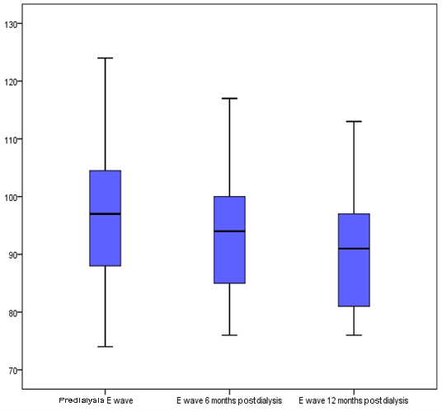

Figure (7): Boxplot of pre-dialysis E wave and after 6 &12 months of hemodialysis among the studied patients
Table (12) Correlation between pre-dialysis serum uric acid pre-dilysis LV ejection fraction:
Normal level of serum uric acid | Spearman correlation  Coefficient | P value
LV ejection fraction | .628 | .012(S)
Increased level of serum uric acid | Spearman correlation  Coefficient | P value
LV ejection fraction | -.981 | .000(HS)

Table (12) shows that there was significant positive correlation between baseline serum uric acid at normal level (p ˂ 0.05) and LV ejection fraction. There was significant negative correlation between baseline serum uric acid at high level (hyperuricemia) and LV ejection fraction (p ˂ 0.05).

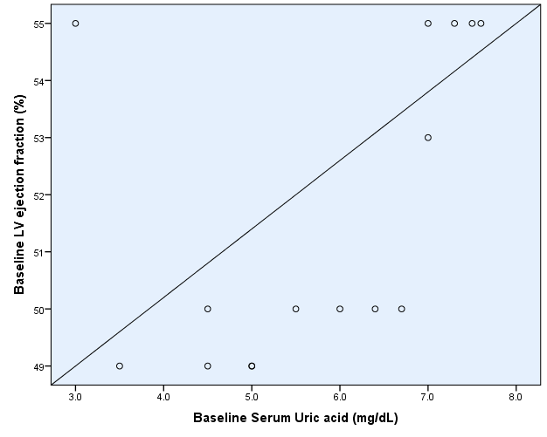

Figure (6): Correlation between baseline serum uric acid at normal level and baseline LV ejection fraction

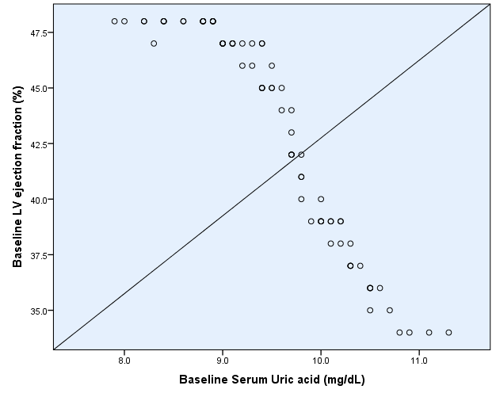

Figure (7): Correlation between hyperuricemia and baseline LV ejection fraction

Table (13) correlation between serum uric acid and LV ejection fraction post-dialysis:

Normal level of serum uric acid  (mg/dl) | Spearman correlation  Coefficient | P value
LV ejection fraction (%) | 0.57 | .026(S)
Decreased level of serum uric acid  (mg/dl) | Spearman correlation  Coefficient | P value
LV ejection fraction (%) | .637 | .03 (S)

Table (13) shows that there was significant positive correlation between serum uric acid at normal level after dialysis (p ˂ 0.05) and LV ejection fraction after dialysis. There was significant negative correlation between serum uric acid at high level after dialysis (hyperuricemia) and LV ejection fraction after dialysis (p = 0.000). There was significant positive correlation between serum uric acid at low level after dialysis (p ˂ 0.05) and LV ejection fraction after dialysis.
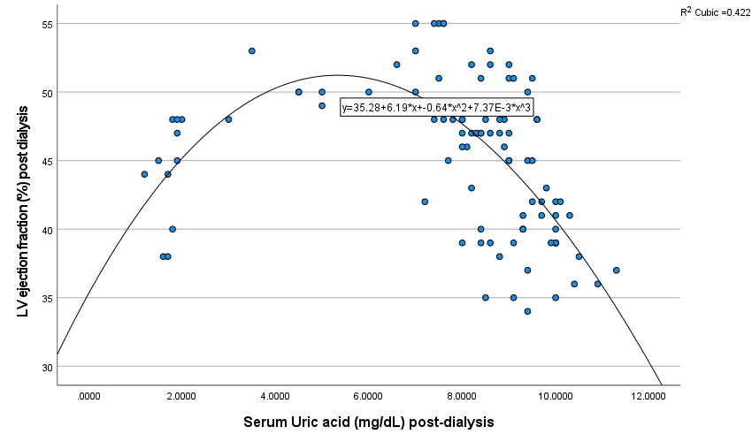
Figure (8): Correlation between serum uric acid and LV ejection fraction after dialysis

Increased level of serum uric acid  (mg/dl) | Spearman correlation  Coefficient | P value
LV ejection fraction (%) | -0.549 | 0.000 (HS)
Table (14) Correlation between pre-dialysis serum uric acid and LV tissue doppler parameters:
Serum uric acid | Spearman correlation | P value
Left ventricular mass | -0.164 | 0.104
E wave | 0.21 | .03 (S)
A wave | 0.159 | 0.114
S wave | 0.270 | 0.000 (HS)
E′ wave | -0.222 | .02 (S)
Table (14) shows that there was significant positive correlation between baseline serum uric acid and E & S waves among the studied patients (p =03 & 0.000). There were significant negative correlations between baseline serum uric acid and E′ wave among the studied patients (p ˂ 0.05).
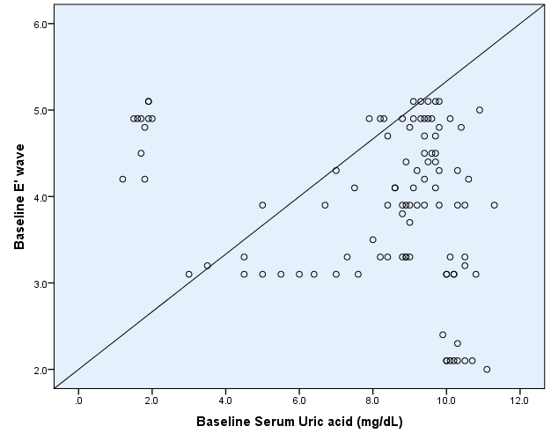
Figure (9): Correlation between baseline serum uric acid and baseline E’ wave

Table (15) Correlation between post-dialysis serum uric acid and LV tissue dopppler parameters:
Serum uric acid | Spearman correlation | P value
Left ventricular mass | .140 | .164
E wave | .237 | .018 (S)
A wave | .014 | .889
S wave | .247 | .013 (S)
E′ wave | -.246 | .014 (S)
Table (15) shows that there was significant positive correlation between serum uric acid level after dialysis and E & S waves after dialysis among the studied patients (p =013). There were significant negative correlations between baseline serum uric acid and E′ wave among the studied patients (p =014).
Table (16) Correlation between pre- and post-uric acid difference and all LV parameters:
Pre- and post-Serum uric acid difference  (Mean ± SD= 0.45±0.69) | Pearson correlation | P value
LV EF % | .223 | .026  (S)
Left ventricular mass (g) | .021 | .837
LVMI (g/m2) | -.026 | .795
E wave (ms) | -.003 | .980
A wave (ms/s) | .063 | .530
S wave (cm/sec) | .118 | .241
E′ wave (cm/sec) | -.079 | .432

Table (16) shows that there was significant correlation between change of uric acid pre- and post-dialysis and left ventricular ejection fraction and there were no significant correlations between uric acid change pre- and post-dialysis and A, S, E, E` Waves, LV mass and LV mass index.
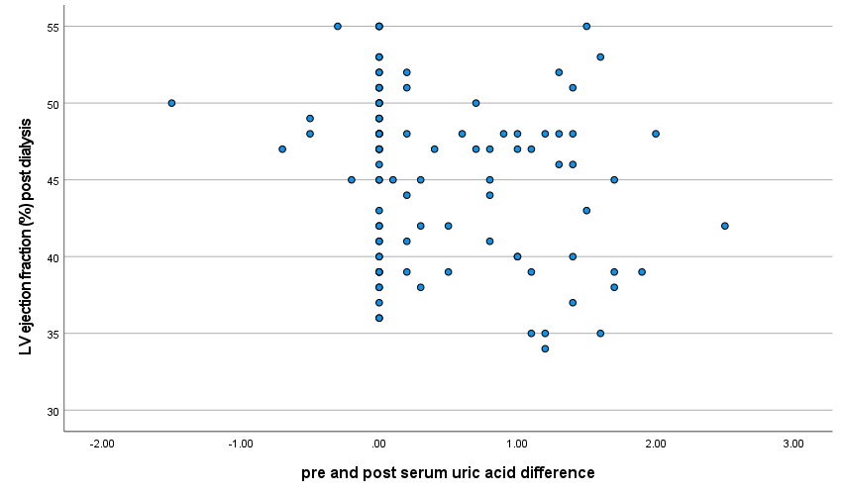
Correlation between pre-and post-uric acid difference and LV ejection fraction post dialysis

Table (20): Linear regression analysis for predictors of baseline LV ejection fraction:
Predictors | (B) | 95% CI | P value
Baseline serum uric acid (mg/dL) | -.720 | -1.08 -  -.352 | .000  (HS)

Table (20) shows that serum uric acid is a significant predictor of LV ejection fraction.
Discussion
Uric acid is the end product of purine metabolism in humans, and despite being a major antioxidant in human plasma, it both correlates and predicts development of conditions associated with oxidative stress. Thus, in the general population, an elevation of serum UA has been shown to be associated with an increased risk of hypertension (Grayson etal.,2011), diabetes mellitus (Bandaru and Shankar.,2011), coronary heart disease (Li etal.,2016), cardiovascular disease (Kivity etal., 2013), stroke (Li etal.,2014) and all-cause and CV mortality (Zhao etal.,2013).
An elevated UA level is commonly observed in CKD patients, and although two meta-analyses showed that higher serum UA levels were associated with higher all-cause and CV mortality in patients with CKD (Luo etal.,2019_ Xia etal.,2016), the role of UA in CKD progression is still under debate (Kumagai etal., 2017_ Nacak etal.,2015).
However, regarding hemodialysis (HD) patients, the impact of UA level on their morbidity and mortality remains more obscure and quite controversial. Serum UA levels have a wide range in HD patients. Studies have reported serum UA levels ≥7 mg/dL to be present in 40–80% of all HD patients (Latif etal.,2011_ Bae etal.,2016).
Better survival has been consistently reported in patients with higher serum UA levels and ESRD who receive HD, compared to patients with CKD not receiving dialysis. While causal relationships cannot be inferred from epidemiologic observations, a review of the literature on serum levels of UA reveals varying results based on clinical context, UA capacity to scavenge oxygen radicals, UA derivation (extracellular vs intracellular), presence of chemical compounds that interfere with UA function or distribution between compartments, or ability to remove surplus UA with renal replacement therapy. If higher serum UA levels confer cardiac protection and better survival in patients receiving HD, the mechanisms of this effect remain speculative (Murea and Tucker.,2019).
Many studies involving HD patients have shown an inverse association between serum UA and CV and/or all-cause mortality (Latif etal .,2011_ Bae etal .,2016), however, some studies have reported either increased or no difference in mortality (Hsu etal .,2004_ Muela etal .,2015). In the HD population, the higher UA concentrations represent better nutritional status (Beberashvili etal.,2015), and concentrations were inversely correlated with markers of malnutrition and inflammation. In this association, UA shows a paradoxical correlation with some traditional CV risk factors and uremia-related factors.
Left ventricular hypertrophy (LVH) with multifactorial etiology is an important predictor of CV mortality and morbidity in HD patients. In the last decade, numerous cross-sectional clinical studies have investigated the association between UA and LVH in the general population, hypertensive cohorts and patients with diabetes and renal failure (Zeng etal .,2017).
The Pressioni Arteriose Monitorate E Loro Associazioni 10-year follow-up study (Cuspidi etal., 2017) is the first study that showed UA is a predictor of long-term echocardiographic changes from normal LVMI to LVH in a community sample.
The main aim of this study was to study the association of pre- and post-dialysis uric acid difference to left ventricular structural and functional disorders in maintenance hemodialysis patients.
This prospective observational study was conducted in the hemodialysis unit in Benha University. This study was conducted on 100 ESRD Patients.
The main results of this study were as follows:
Regarding the demographic characteristics of the studied patients, the current study revealed that 54 % of the studied patients were males, the mean +_ SD of the age of studied patients were 39.6 +_13.4 years old and mean +_ SD of BMI of studied patients were 27.6+_5.3 kg/m2.
In line with the present study Khodeir et al., (Khodeir etal .,2018) evaluated the the relation between blood pressure level and serum uric acid level in chronic hemodialysis patients and enrolled 200 HD patients included 77 (38.5%) males and 123 (61.5%) females with the average age was 19–75 years with mean 49.77± 13.07 years, the mean BMI in this study was 25.30±2.18.
Also, Roozbeh et al., (Roozbeh et al.,2015) studied the impact of high uric acid level on blood pressure in HD patients. The study enrolled 60 (65.9%) males and 31 (34.1%) females and the average age was 50.8 ± 16.7 years. The mean BMI was 24.1 ±5.4.
Bae et al., (Bae et al.,2016) who investigated the relation between lower serum uric acid level and mortality in dialysis patients stated that 45.2% were women and 54.8% were men and the mean age was 56 ± 13 years. The mean BMI was 22.8 ±3.3. The differences in findings may be due to different sample size.
Also, regarding laboratory findings among the studied patients we found that the mean +_ SD of serum sodium, potassium, calcium and phosphorus level of the studied patients were 143+_5.9 mEq/L, 5.37 +_0.4 mEq/L, 8.7+_0.7 mg/dL and 4.7+_1.38 mg/dL respectively. The mean +_SD CRP level of the studied patients was 4.5+_0.8 mg/L.
in agreement with our study (jeena etal.,2022_mohd.,2020_lobo etal., 2013) that there was positive correlation between SUA and CRP level in CKD patients starting hemodialysis.
The current study showed that there were high statistically significant differences between the studied patients systolic and diastolic blood pressure before and after hemodialysis (p ˂ 0.001). The mean+_SD of systolic blood pressure (133.6 +_14.3 mmHg) and diastolic blood pressure (84.4+_5.13 mmHg) of the studied patients had significantly decreased after hemodialysis.
Hypertension is a common finding in hemodialysis patients and it occurs in up to 85% of them (Sergio etal.,2019). In these patients’ multiple factors can cause high blood pressure including fluid overload, activation of rennin angiotensin-aldosterone axis or use of exogenous erythropoietin that make it difficult to evaluate the causative mechanism (Sturm etal.,2008).
In agreement with our results Sun et al., (Sun et al.,2019) reported that SBP and DBP decreased significantly following the hemodialysis; the differences were 20.13 ± 16.06 mmHg and 12.57 ± 11.87 mmHg, respectively (p < .001).
Also, in agreement with our results Rootjes et al., (Rootjes et al.,2020) reported that mean pre- and post-dialysis SBP, DBP, and mean arterial pressure (MAP), declined significantly during follow-up (pre-dialytic: SBP −2.16 mm Hg, DBP −2.88 mm Hg, MAP −2.64 mm Hg), and pulse pressure (PP) increased (pre-dialytic 0.96 mm Hg).
As well, Teama et al., (Teama et al., 2021) revealed that both SBP and DBP decreased significantly after hemodialysis.
Regarding the differences between serum uric acid, creatinine, and urea levels before and after hemodialysis among studied patients, our study showed that there were high statistically significant differences between the studied patients serum level of uric acid, creatinine and urea before and after hemodialysis (p ˂ 0.001). The mean +_SD of serum level of uric acid, creatinine and urea of the studied patients had significantly decreased after hemodialysis (7.7+_2.6, 5 +_0.8 and 92.4+_15.1 mg/dl respectively).
Uric acid levels are high in renal failure patients due to decreased clearance (Bobulescu and Moe.,2012). Dialysis can remove uric acid from blood partially (Durante etal.,2010). Higher uric acid levels are shown to be associated with higher mortality in hemodialysis patients (Liu etal.,2012).
Hyperuricemia is common in patient with end-stage renal disease, which has been reported in up to 50% of subjects, probably due to deficiency in UA excretion (Lee etal.,2009).
In agreement with our results Khodeir et al., (Khodeir et al., 2018) reported that mean pre-dialysis serum uric acid was 6.56± 1.85mg/dl while the post dialysis serum uric acid was mean 3.2±2.24mg/dl. There was a significant reduction in serum uric acid after hemodialysis.
Also, in agreement with our results Alaraj et al., (Alaraj et al., 2017) reported that Kidney function blood tests demonstrated significant decrease in creatinine, uric acid and urea levels in post-dialysis samples in comparison with pre-dialysis samples (p < 0.001) with a percent reduction of 57.62 ± 9.85, 64.14 ± 18.8 and 67.03 ± 11.4, respectively.
Regarding the differences between E wave before and after dialysis among studied patients, we found that there were high statistically significant differences between the studied patients E wave level before and after 6 and 12 months of hemodialysis (p ˂ 0.001). There was statistically significant decrease of patients E wave after 6 and 12 months of hemodialysis (p ˂ 0.001). The mean +_ SD of E wave level before hemodialysis and after 6 and 12 months of hemodialysis were (96.3+_11.5ms), (93.5+_9.9ms) and (90.6+_9.23ms) respectively.
In agreement with our results Şenöz et al., (Şenöz et al., 2022) enrolled 38 patients with mean dialysis time 6.3±3.9 years. And revealed that Pulsed Doppler echocardiography showed significantly decreased E wave peak velocity (99.3±38.2 vs. 80.4±27.8 cm/s, p=0.001).
Also, in agreement with our results Mostafa et al., (Mostafa et al.,2018) reported that E wave significantly decreased from baseline 125.5 ±26.7 to post dialysis value of 91.7 ±28.8 (p< 0.001).
As well, Wang et al., (Wang et al.,2021) revealed that there were high statistically significant differences between the studied patients E wave level before and after hemodialysis (82.22±20.13 vs. 72.43±18.32, p ˂ 0.001).
Regarding the differences between A wave before and after dialysis among studied patients, we found that there was no significant difference between the studied patients A wave level before and after 6 and 12 months of hemodialysis (p > 0.05).
In agreement with our results Mostafa et al., (Mostafa et al., 2018) reported that there was no significant difference between the studied patients A wave level before and after hemodialysis (p > 0.05). The same results were reported by Wang et al., (Wang et al.,2021).
However, Şenöz et al., (Şenöz et al.,2022) revealed that Pulsed Doppler echocardiography showed significantly decreased A wave peak velocity (99.4±23.2 vs. 90.4±25.5 cm/s). The disagreement may be due to the difference in sample size.
Regarding the differences between S wave before and after dialysis among studied patients, we found that there was high statistically significant decrease of patients S wave after 6 and 12 months of hemodialysis (p ˂ 0.001). The mean ± SD of S wave level before hemodialysis and after 6 and 12 months of hemodialysis were (3.89 ± 0.63), (3.79 ± 0.60) and (3.58 ± 0.55) cm/sec respectively.
In agreement with our results Mostafa et al., (Mostafa et al., 2018) reported there was high statistically significant decrease of patients S wave after hemodialysis (p ˂ 0.001).
However, Wang et al., (Wang et al.,2021) reported that there was no significant difference in S wave between ore and post dialysis.
Regarding the differences between E′ wave before and after dialysis among studied patients, we found that there were high statistically significant differences between the studied patients E′ wave before and after 6 and 12 months of hemodialysis (p ˂ 0.001). E′ wave significantly increased after 6 and 12 months of hemodialysis. The mean +_SD of E′ wave before and after 6 and 12 months of hemodialysis were (3.9+– 0.89), (4.42 +_ 0.55) and (4.54+_0.61) cm/sec respectively.
In agreement with our results Mostafa et al., (Mostafa et al., 2018) reported there was high statistically significant decrease of patients E′ wave after hemodialysis (p ˂ 0.001).
Regarding the differences between LV ejection fraction pre and post dialysis among studied patients, we found that there were high statistically significant differences between the studied patients LV ejection fraction before and after 6 and 12 months of hemodialysis (p ˂ 0.001). LV ejection fraction has significantly increased on 6 and 12 months follow up after hemodialysis. The mean +_SD of LV ejection fraction before and after 6 and 12 months of hemodialysis were (44.2+_5.5 %), (44.6- 5.5%) and (45.2+_5.4%) respectively.
In agreement with our results Wang et al., (Wang et al.,2021) reported that there were high statistically significant differences between the studied patients LV ejection fraction before and after hemodialysis (p =0.049).
Also, in agreement with our results Abdelrehim et al., (Abdelrehim et al., 2021) reported that there were high statistically significant differences between the studied patients LV ejection fraction before and after hemodialysis (p ˂ 0.001).
However, Şenöz et al., (Şenöz et al.,2022) revealed that there was no significant difference between pre- and post-dialysis LV ejection fraction. The same results were reported by Mostafa et al., (Mostafa et al., 2018).
The present study showed that there was an inverted U-shaped relationship between uric acid and LVEF. However, some studies (Crawley etal.,2022_ Wang etal.,2020_Adam etal.,2020) have reported that there was a U-shaped relationship also between uric acid and all causes of mortality.
Regarding the differences between LV mass pre and post dialysis among studied patients, we found that there were high statistically significant differences between the studied patients left ventricular mass before and after 6 and 12 months of hemodialysis (p ˂ 0.001). Left ventricular mass has significantly decreased on 6 and 12 months follow up after hemodialysis. The mean +_SD of left ventricular mass before and after 6 and 12 months of hemodialysis were (42.5 +_6.9 g), (40.9 +_7.2 g) and (40.2 +_6.6 g) respectively.
Glassock et al., (Glassock et al., 2009) stated that increased LVM has been well described as a frequent component of ESRD.
In agreement with our findings Mishra et al., (Mishra et al., 2013) reported that there were significant reductions in both LV mass and volumes and these reductions are significantly correlated with reductions in pre-dialysis systolic BP.
regarding the differences between LV mass index before and after dialysis among studied patients, we found that there were high statistically significant differences between the studied patients left ventricular mass index before and after 6 and 12 months of HD (p <0.001). LVMI has significantly decreased on 6 and 12 months follow up after HD. the mean +_SD of LVMI were (26.9+_6.88 g/m2), (24.8+_5.3 g/m2) and (24.3+_5.1g/m2) respectively.
In agreement with our findings Chen et al., (Chen et al.,2013) stated that increased uric acid associated with high LVMI and LVMI decline with efficient sessions of dialysis and decrease volume over load.
The present study showed that there was significant positive correlation between baseline serum uric acid at normal level (p ˂ 0.05) and LV ejection fraction. There were significant negative correlations between baseline serum uric acid at high level (hyperuricemia) and LV ejection fraction (p ˂ 0.05).
After 1 year of dialysis, we found that there was significant positive correlation between serum uric acid at normal level after dialysis (p ˂ 0.05) and LV ejection fraction after dialysis. There was significant negative correlation between serum uric acid at high level after dialysis (hyperuricemia) and LV ejection fraction after dialysis (p = 0.000). There was significant positive correlation between serum uric acid at low level after dialysis (p ˂ 0.05) and LV ejection fraction after dialysis.
Regarding the correlation between pre-dialysis serum uric acid and LV parameters, we found that there was significant positive correlation between baseline serum uric acid and E & S waves among the studied patients (p =03 & 0.000). There was significant negative correlation between baseline serum uric acid and E′ wave among the studied patients (p ˂ 0.05). However, there was no significant correlation between baseline serum creatinine and LV parameters among the studied patients (p >.05). Also, there was no significant correlation between baseline serum urea level and LV parameters among the studied patients (p >.05).
After 1 year of dialysis, our results showed that there was significant positive correlation between serum uric acid level after dialysis and E & S waves after dialysis among the studied patients (p =013). There were significant negative correlations between baseline serum uric acid and E′ wave among the studied patients (p =014).
In agreement with our results Ivan et al., (Ivan et al.,2021) reported that a direct relationship between the level of serum uric acid and the ejection fraction was established (p = 0.03); patients with higher uric acid had an increased risk of having a lower ejection fraction.
Also, Ezzat et al., (Ezzat et al., 2019) concluded that Higher serum uric acid levels are significantly correlated with the severity of congestive heart failure and left ventricular ejection fraction.
Regarding correlation between uric acid difference pre- and post- dialysis with all LV parameters there was significant correlation between change of uric acid pre- and post-dialysis and left ventricular ejection fraction and there were no significant correlations between uric acid change pre- and post-dialysis and A, S, E, E` waves and LV mass.
Our results were supported by Ezzat et al., 2019 who revealed that higher serum uric acid levels are significantly correlated with the severity of congestive heart failure and left ventricular ejection fraction. Also, according to (Gjulsen etal.,2019) there was significant association with FA_UA group with CV mortality and LVH in hemo-dialysis patients
In contrast to our results (Kim et al., 2021) revealed that there were parameters there was significant correlation between uric acid and left ventricular ejection fraction in pre-dialysis CKD but they reported that the serum uric acid was associated with left ventricular hypertrophy (LVH) and left ventricular diastolic dysfunction (LVDD). The disagreement was due to the difference in inclusion criteria.
The metabolic abnormalities that arise from the continuous reduction of ejection fraction are potential contributing causes for hyperuricemia in these patients. Uric acid, being a byproduct of purine metabolism in light of recent data, is a contributing factor to the development of heart failure, alongside other known prognostic factors in HF (Spoletini etal .,2019_ Doehner etal.,2016).
Linear regression analysis for predictors of baseline LV ejection fraction, showed that serum uric acid is a significant predictor of LV ejection fraction.
This was supported by Oki et al., (Oki et al.,2019) as they concluded that a high serum uric acid is a direct risk factor for cardiac dysfunction.
Also, Kim et al., (Kim et al.,2021) concluded that the serum uric acid level was an independent predictor of LVD and LVDD in patients with CKD, suggesting that serum uric acid could be a biomarker for LVH and LVDD.
Furthermore, Selim et al., (Selim et al.,2020) concluded that in HD patients the prolonged exposure to hypouricemia is associated with left ventricular hypertrophy. This paradoxical association can only be explained by the hypothesis that uremic milieu in HD patients changes the influence of uric acid.
Conclusion
In ESRD patients, hemodialysis was associated with significant reduction of SBP, DBP, uric acid, creatinine and urea, it was also associated with significant reduction in E & S waves, significant reduction Left ventricular mass while there was significant increase in E′ wave and LV ejection fraction.
The current study showed that there was significant correlation between uric acid and LV ejection fraction as well as LV parameters. In regression analysis we found that serum uric acid was a significant predictor of LV ejection fraction. Further studies with larger sample size and longer follow-up are needed to confirm our results and to identify risk factors of adverse events.
There was significant correlation between pre- and post-dialysis serum uric acid difference and left ventricular ejection fraction.
Further studies with larger sample size and longer follow-up are needed to confirm our results and to identify risk factors of adverse event.

References:
- Abdelrehim AB, Ahmed AA, Elgendi SS, Muhammad WH. Study of Ventricular Interdependence in Hemodialysis Patients.
- Ahmad MI, Dutta A, Anees MA, et al. Interrelations Between Serum Uric Acid, Silent Myocardial Infarction, and Mortality in the General Population. Am J Cardiol. 2019;123:882–888.
- Alaraj M, Al-Tamimi N, Rayyan W, Alshammari F, Al-Trad B, Alfouzan F. Role of age and uric acid levels on dialysis efficacy among end stage renal disease patients in Saudi Arabia. J Res Med Dent Sci. 2017;4(2):92-6.
- Bae E, Cho HJ, Shin N et al. Lower serum uric acid level predicts mortality in dialysis patients. Medicine (Baltimore) 2016; 95: e3701.
- Bae E, Cho HJ, Shin N, et al. Lower serum uric acid level predicts mortality in dialysis patients. Medicine (Baltimore). 2016; 95:e3701.
- Bandaru P, Shankar A. Association between serum uric acid levels and diabetes mellitus. Int J Endocrinol 2011; 2011: 604715.
- Beberashvili I, Erlich A, Azar A, et al. Longitudinal Study of Serum Uric Acid, Nutritional Status, and Mortality in Maintenance Hemodialysis Patients. Clin J Am Soc Nephrol. 2016;11:1015–1023.
- Beberashvili I, Sinuani I, Azar A et al. Serum uric acid as a clinically useful nutritional marker and predictor of outcome in maintenance hemodialysis patients. Nutrition 2015; 31: 138–147
- Beberashvili I, Sinuani I, Azar A, et al. Serum uric acid as a clinically useful nutritional marker and predictor of outcome in maintenance hemodialysis patients. Nutrition. 2015;31: 138–147.
- Bengtsson C, Lapidus L, Stendahl C, et al. Hyperuricaemia and risk of cardiovascular disease and overall death. A 12- year follow-up of participants in the population study of women in Gothenburg, Sweden. Acta Med Scand. 1988;224: 549–555.
- Bobulescu IA, Moe OW. Renal transport of uric acid: evolving concepts and uncertainties. Adv Chron Kidney Dis. 2012;19: 358–371.
- Chen SC, Chang JM, Yeh SM, Su HM, Chen HC. Association of uric acid and left ventricular mass index with renal outcomes in chronic kidney disease. American journal of hypertension. 2013 Feb 1;26(2):243-9.
- Corry DB, Eslami P, Yamamoto K, et al. Uric acid stimulates vascular smooth muscle cell proliferation and oxidative stress via the vascular renin-angiotensin system. J Hypertens. 2008;26:269–275.
- Crawley, W. T., Jungels, C. G., Stenmark, K. R., & Fini, M. A. U-shaped association of uric acid to overall-cause mortality and its impact on clinical management of hyperuricemia. Redox Biology,2022, 102271.
- Cuspidi C, Facchetti R, Bombelli M et al. Uric acid and new onset left ventricular hypertrophy: findings from the PAMELA population. Am J Hypertens 2017; 30: 279–285
- ---Cuspidi C, Valerio C, Sala C et al. Lack of association between serum uric acid and organ damage in a never-treated essential hypertensive population at low prevalence of hyperuricemia. Am J Hypertens 2007; 20: 678–685
- Doehner W., Jankowska E.A., Springer J., Lainscak M., Anker S.D. Uric Acid and Xanthine Oxidase in Heart Failure—Emerging Data and Therapeutic Implications. Int. J. Cardiol. 2016;213:15–19.
- Durante P, Chávez M, Pérez M, Romero F, Rivera F. Effect of uric acid on hypertension progression in spontaneously hypertensive rats. Life sciences. 2010 Jun 19;86(25-26):957-64.
- Ezzat MA, Boghdady AM, Ibrahim KF, Dahab LH. Correlation between Serum Uric Acid Level and Left Ventricular Ejection Fraction in Patients with Congestive Heart Failure. World Journal of Cardiovascular Diseases. 2019 Nov 27;9(11):857.
- Glassock RJ, Pecoits-Filho R, Barberato SH. Left ventricular mass in chronic kidney disease and ESRD. Clinical Journal of the American Society of Nephrology. 2009 Dec 1;4(Supplement 1):S79-91.
- Go AS, Chertow GM, Fan D, et al. Chronic kidney disease and the risks of death, cardiovascular events, and hospitalization. N Engl J Med. 2004;351:1296–1305.
- Grayson PC, Kim SY, LaValley M et al. Hyperuricemia and incident hypertension: a systematic review and meta-analysis. Arthritis Care Res 2011; 63: 102–110.
- Hsu SP, Pai MF, Peng YS et al. Serum uric acid levels show a ‘J-shaped’ association with all-cause mortality in haemodialysis patients. Nephrol Dial Transplant 2004; 19: 457–462
- Hsu SP, Pai MF, Peng YS, et al. Serum uric acid levels show a ’J-shaped’ association with all-cause mortality in haemo- dialysis patients. Nephrol Dial Transplant. 2004;19:457–462.
- Hsu WL, Li SY, Liu JS, et al. High uric acid ameliorates indoxyl sulfate-induced endothelial dysfunction and is asso- ciated with lower mortality among hemodialysis patients. Toxins (Basel). 2017;9:20.
- Ivan VS, Buzas R, Cuțina Morgovan AF, Ciubotaru P, Ardelean M, Goje D, Roșca CI, Timar R, Lighezan D. The Relationship between Serum Uric Acid and Ejection Fraction of the Left Ventricle. Journal of Clinical Medicine. 2021 Sep 6;10(17):4026.
- Iwashima Y, Horio T, Kamide K et al. Uric acid, left ventricular mass index, and risk of cardiovascular disease in essential hypertension. Hypertension 2006; 47: 195–202
- Khodeir SA, Mohammed FA, Ghada AS, Mabrouk R. The Relationship between Blood Pressure Level and Serum Uric Acid Level in Chronic Hemodialysis Patients. The Medical Journal of Cairo University. 2018 Sep 1;86(September):2953-8.
- Kim CS, Jin DC, Yun YC, et al. Relationship between serum uric acid and mortality among hemodialysis patients: retro-
- Kim IY, Ye BM, Kim MJ, Kim SR, Lee DW, Kim HJ, Rhee H, Song SH, Seong EY, Lee SB. Association between serum uric acid and left ventricular hypertrophy/left ventricular diastolic dysfunction in patients with chronic kidney disease. PloS one. 2021 May 6;16(5):e0251333.
- Kivity S, Kopel E, Maor E et al. Association of serum uric acid and cardiovascular disease in healthy adults. Am J Cardiol 2013; 111: 1146–1151.
- Kumagai T, Ota T, Tamura Y et al. Time to target uric acid to retard CKD progression. Clin Exp Nephrol 2017; 21: 182–192
- Lang RM, Bierig M and Devereux RB (2005): recommendations for chamber quantification: a report from the American society of echocardiography's guidelines and standards committee and the chamber quantification writing group, developed in con-junction with the European association of echocardiography. A branch of the European society of cardiology. Journal of the American Society of Echocardiography; 12(18):1440–1463.
- Latif W, Karaboyas A, Tong L et al. Uric acid levels and all cause and cardiovascular mortality in the hemodialysis population. Clin J Am Soc Nephrol 2011; 6: 2470–2477
- Latif W, Karaboyas A, Tong L, et al. Uric acid levels and all- cause and cardiovascular mortality in the hemodialysis pop- ulation. Clin J Am Soc Nephrol. 2011;6:2470–2477.
- Lee SK, Lee AL, Winters TJ, Tam E, Jaleel M, Stenvinkel P, Johnson RJ. Low serum uric acid level is a risk factor for death in incident hemodialysis patients. American journal of nephrology. 2009;29(2):79-85.
- Lee SM, Lee AL, Winters TJ et al. Low serum uric acid level is a risk factor for death in incident hemodialysis patients. Am J Nephrol 2009; 29: 79–85
- Li M, Hou W, Zhang X et al. Hyperuricemia and risk of stroke: a systematic review and meta-analysis of prospective studies. Atherosclerosis 2014; 232: 265–270.
- Li M, Hu X, Fan Y et al. Hyperuricemia and the risk for coronary heart disease morbidity and mortality a systematic review and dose-response meta-analysis. Sci Rep 2016; 6: 19520.
- Liu WC, Hung CC, Chen SC, Yeh SM, Lin MY, Chiu YW, Kuo MC, Chang JM, Hwang SJ, Chen HC. Association of hyperuricemia with renal outcomes, cardiovascular disease, and mortality. Clinical Journal of the American Society of Nephrology. 2012 Apr 1;7(4):541-8.
- Luo Q, Xia X, Li B et al. Serum uric acid and cardiovascular mortality in chronic kidney disease: a meta-analysis. BMC Nephrol 2019; 20: 18.
- Maesaka JK, Fishbane S. Regulation of renal urate excretion: a critical review. American journal of kidney diseases. 1998 Dec 1;32(6):917-33.
- Masuo K, Kawaguchi H, Mikami H, et al. Serum uric acid and plasma norepinephrine concentrations predict subsequent weight gain and blood pressure elevation. Hypertension. 2003;42:474–480.
- Mishra RK, Dubin RF. The effects of frequent hemodialysis on left ventricular mass, volumes, and geometry. Clinical Journal of the American Society of Nephrology. 2013 Dec 6;8(12):2025-7.
- Mostafa FA, Sad IA, Elshamaa MF, Badr AM, Eldayem SA, Ashmawy I, Abd Elrahim YA. Left ventricular dysfunction by conventional and tissue Doppler echocardiography in pediatric hemodialysis patients: relation with plasma brain natriuretic peptide levels. Archives of Medical Science-Atherosclerotic Diseases. 2018 Feb 7;3(1):18-28.
- Muela HC, De Lima JJ, Gowdak LH et al. Prognostic value of serum uric acid in patients on the waiting list before and after renal transplantation. Int J Nephrol 2015; 2015: 1
- Muiesan ML, Agabiti-Rosei C, Paini A, et al. Uric acid and cardiovascular disease: an update. Eur Cardiol. 2016;11:54–59.
- Murea M, Tucker BM. The physiology of uric acid and the impact of end-stage kidney disease and dialysis. Semin Dial 2019; 32: 47–57
- Murea M, Tucker BM. The physiology of uric acid and the impact of end-stage kidney disease and dialysis. Semin Dial. 2019;32:47–57.
- Nacak H, van Diepen M, Qureshi AR et al. Uric acid is not associated with decline in renal function or time to renal replacement therapy initiation in a referred cohort of patients with Stage III, IV and V chronic kidney disease. Nephrol Dial Transplant 2015; 30: 2039–2045
- Oki Y, Kawai M, Minai K, Ogawa K, Inoue Y, Morimoto S, Tanaka T, Nagoshi T, Ogawa T, Yoshimura M. High serum uric acid is highly associated with a reduced left ventricular ejection fraction rather than increased plasma B-type natriuretic peptide in patients with cardiovascular diseases. Scientific reports. 2019 Jan 24;9(1):1-2.
- Park C, Obi Y, Streja E, et al. Serum uric acid, protein intake and mortality in hemodialysis patients. Nephrol Dial Trans- plant. 2017;32:1750–1757.
- Rootjes PA, van Zuijdewijn CL, Grooteman MP, Bots ML, Canaud B, Blankestijn PJ, van Ittersum FJ, Maduell F, Morena M, Peters SA, Davenport A. Long-term peridialytic blood pressure patterns in patients treated by hemodialysis and hemodiafiltration. Kidney international reports. 2020 Apr 1;5(4):503-10.
- Roozbeh J, Sagheb MM, Vafaie E. The association between blood pressure level and serum uric acid concentration in hemodialysis patients. Journal of Nephropathology. 2015 Jul;4(3):85.
- Salem MM. Hypertension in the hemodialysis population: a survey of 649 patients. American journal of kidney diseases. 1995 Sep 1;26(3):461-8.
- Sarhene M., Wang Y., Wei J., Huang Y., Li M., Li L., Acheampong E., Zhou Z., Qin X., Xu Y. Biomarkers in Heart Failure: The Past, Current and Future. Heart Fail. Rev. 2019;24:867–903.
- Selim G, Kabova A, Bexheti B, Janevski Z, Spasovska Vasilova A, Milenkova M, Canevska A, Vrevezoska B, Muharremi S. P1250 Low Serum Uric Acid Level and Left Ventricular Hypertrophy: The New Paradoxical Association in Hemodialysis Patients. Nephrology Dialysis Transplantation. 2020 Jun 1;35(Supplement_3): gfaa142-P1250.
- Şenöz O, Atay G, Yurdam FS, Emren ZY, Erseçgin A, Arda HÜ. The effect of hemodialysis on left ventricular global longitudinal strain in chronic hemodialysis patients with preserved left ventricular ejection fraction. Cardiovascular Surgery and Interventions. 2022;9(1):020-6.
- Silbernagel G, Hoffmann MM, Grammer TB, et al. Uric acid is predictive of cardiovascular mortality and sudden cardiac death in subjects referred for coronary angiography. Nutr Metab Cardiovasc Dis. 2013;23:46–52.
- spective analysis of Korean end-stage renal disease registry data. Kidney Res Clin Pract. 2017;36:368–376.
- Spoletini I., Coats A.J.S., Senni M., Rosano G.M.C. Monitoring of Biomarkers in Heart Failure. Eur. Heart J. Suppl. 2019;21:M5–M8.
- Sturm G, Kollerits B, Neyer U, Ritz E, Kronenberg F, MMKD Study Group. Uric acid as a risk factor for progression of non-diabetic chronic kidney disease? The Mild to Moderate Kidney Disease (MMKD) Study. Experimental gerontology. 2008 Apr 1;43(4):347-52.
- Suliman ME, Johnson RJ, Garcia-Lopez E, et al. J-shaped mortality relationship for uric acid in CKD. Am J Kidney Dis. 2006;48:761–771.
- Sun G, Hao R, Zhang L, Shi X, Hei K, Dong L, Wei F, Jiang A, Li B, Li X, Ke Y. The effect of hemodialysis on ocular changes in patients with the end-stage renal disease. Ren Fail. 2019 Nov;41(1):629-635.
- Teama NM, Soliman HS, ElSharkawy M, El-Sharabasy RM. Impact of Hemodialysis Time Prolongation on Blood Pressure Control. The Egyptian Journal of Hospital Medicine. 2021 Apr 1;83(1):949-56.
- Thomas L, Levett K, Boyd A, et al. (2003): Changes in regional left atrial function with aging: evaluation by Doppler tissue imaging. European Journal of Echocardiography; 2(4):92–100.
- Vanholder RC, De Smet RV, Ringoir SM. Assessment of urea and other uremic markers for quantification of dialysis efficacy. Clin Chem 1992; 38: 1429–1436
- Wang X, Hong J, Zhang T, Xu D. Changes in left ventricular and atrial mechanics and function after dialysis in patients with end-stage renal disease. Quantitative Imaging in Medicine and Surgery. 2021 May;11(5):1899.
- Wang Z, Xu Y, Liao H, Chen X, He S. U-shaped association between serum uric acid concentration and mortality in hypertrophic cardiomyopathy patients. Upsala Journal of Medical Sciences. 2020 Jan 2;125(1):44-51.
- Xia X, Luo Q, Li B et al. Serum uric acid and mortality in chronic kidney disease: a systematic review and meta-analysis. Metab Clin Exp 2016; 65: 1326–1341.
- Zeng C, Cheng D, Sheng X et al. Increased serum uric acid level is a risk factor for left ventricular hypertrophy but not independent of eGFR in patients with type 2 diabetic kidney disease. J Diabetes Res 2017; 2017: 1
- Zhao G, Huang L, Song M et al. Baseline serum uric acid level as a predictor of cardiovascular disease related mortality and all-cause mortality: a meta-analysis of prospective studies. Atherosclerosis 2013; 231: 61–68.

